16th December 2019

**Dubai Duty Free Marks 36th Anniversary with a 25% Pre-Holiday Sale for 72 Hours**

***Dubai Duty Free will again introduce its annual anniversary promotion for 72 hours with a 25% pre-Christmas sale*.**

**Summary:** In what has become an annual shopping spree celebration, Dubai Duty Free will offer a special 25% discount on a wide range of products over three days starting from the 18th of December until the 20th to mark its 36th anniversary celebration. The 25% discount offer will be available for all departing, transiting and arriving passengers at Dubai International Airport and Al Maktoum International Airport, beginning at midnight on the 17th of December and ending at midnight on the 20th of December.

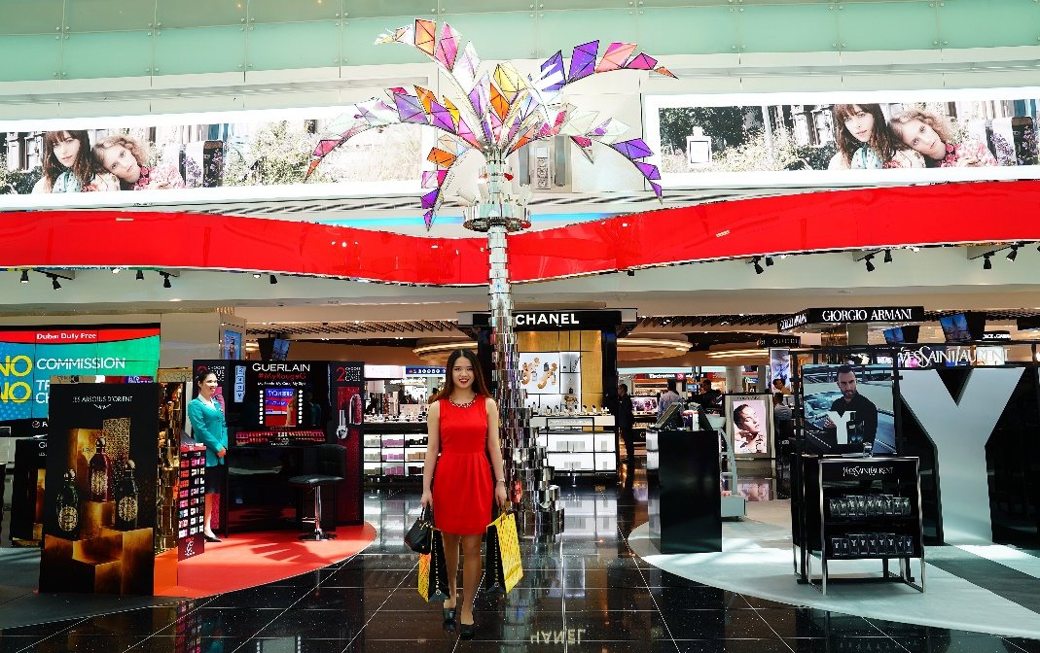

Dubai Duty Free shopping complex in Concourse D

In what has become an annual shopping spree celebration, Dubai Duty Free will offer a special 25% discount on a wide range of products over three days starting from the 18th of December until the 20th to mark its 36th anniversary celebration. The 25% discount offer will be available for all departing, transiting and arriving passengers at Dubai International Airport and Al Maktoum International Airport, beginning at midnight on the 17th of December and ending at midnight on the 20th of December.

Commenting on the anniversary day plans, Colm McLoughlin, Executive Vice Chairman & CEO of Dubai Duty Free said: “The DDF anniversary promotion is now a highly-anticipated event with many travelers choosing to travel on the days when the 25% discount is offered. We started this promotion 16 years ago when we turned 20 and believe that this is a good way of saying thank you to our customers. There is always a terrific atmosphere on the shopfloor during the anniversary day sales with everyone getting caught up in the holiday spirit.”

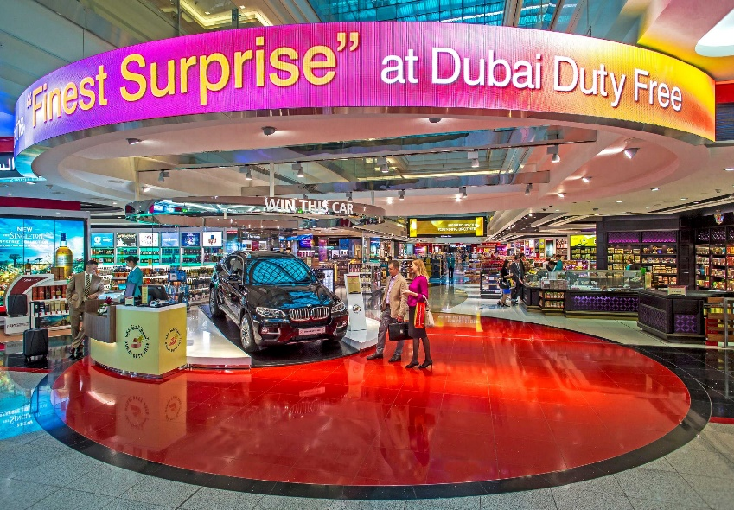

Dubai Duty Free shopping complex in Concourse A

The promotion applies to major categories including Perfumes, Cosmetics, Watches, Confectionary, and Leather goods with the exclusion of certain categories such as Gold, Electronics and select fashion, jewellery, watch and perfume brands. This offer includes the Dubai Duty Free Millennium Millionaire and Finest Surprise tickets on 20th December only.

Customers can also avail of this offer online by pre-ordering or upon collection at the time of payment at Dubai Duty Free shops on the same dates.

As part of the 36th Anniversary celebrations, Dubai Duty Free will ensure a party-like atmosphere throughout the retail operation. Plans are in place to conduct a Millennium Millionaire draw, a Finest Surprise Luxury Car draw and a series of other promotional activities that will involve both travelers and staff.

The anniversary discount offer, which began with Dubai Duty Free’s 20th Anniversary in 2003, has proved so successful and popular that it has now become a much-anticipated travel day.

* Ends -

For further information, please contact Bernard Aquino, Marketing Department,

Dubai Duty Free or call Tel: +9714-6019232 or email: [bernard.aquino@ddf.ae](mailto:bernard.aquino@ddf.ae)